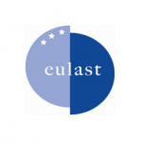
EULAST-II
REIMBURSEMENT FORM COUNTRY COORDINATION

Name account holder
Address
Postal Code
City
Country
IBAN number*
SWIFT code*
Country Coordinator fee | Amount: 1000,- euro
Name:  Date: | Signature:

* both are required for international financial transactions

